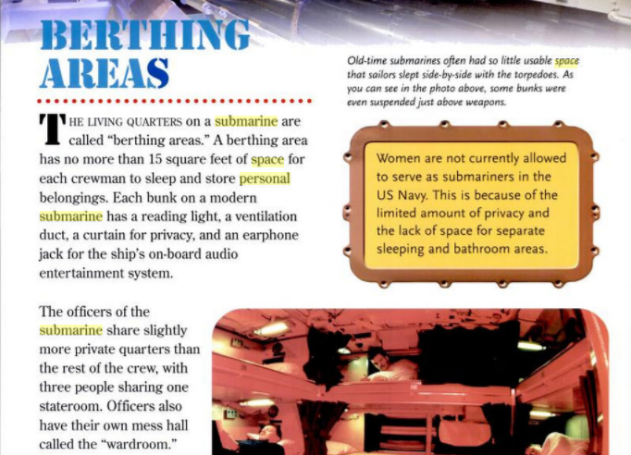

Submarines up Close – Andra Serlin Abramson 2008

Navy.com says deployment ranges from 3-6months

NASA**Study performed under NASA Contract No. NAS 2-11723 for NASA/Ames by the McDonnell Douglas Corp**

Space Station Functional Relationship Analysis (1988)

Talks about the space requirements and how to group different facilities (e.g. meal prep, dining area, conference area, hygiene facilities, personal area, etc) in a habitat. Discusses how some can be combined and others need to be separate.

Yvonne A. Clearwater, Space station habitability research, Acta Astronautica, Volume 17, Issue 2, 1988,

Talks about a program to simulate a habitat back in the 80’s, one key thing they mentioned though was, “The measurement of sheer physical space in any terms of “habitable volume’ (e.g. free volume or floor space) is insufficient to characterize the behavioral, psychological and social consequences (or the human experience in space).”

**Space Station Habitability Recommendations Based on a Systematic Comparative Analysis of Analogous Conditions – Jack Stuster, 1986 https://ntrs.nasa.gov/search.jsp?R=19880015988**

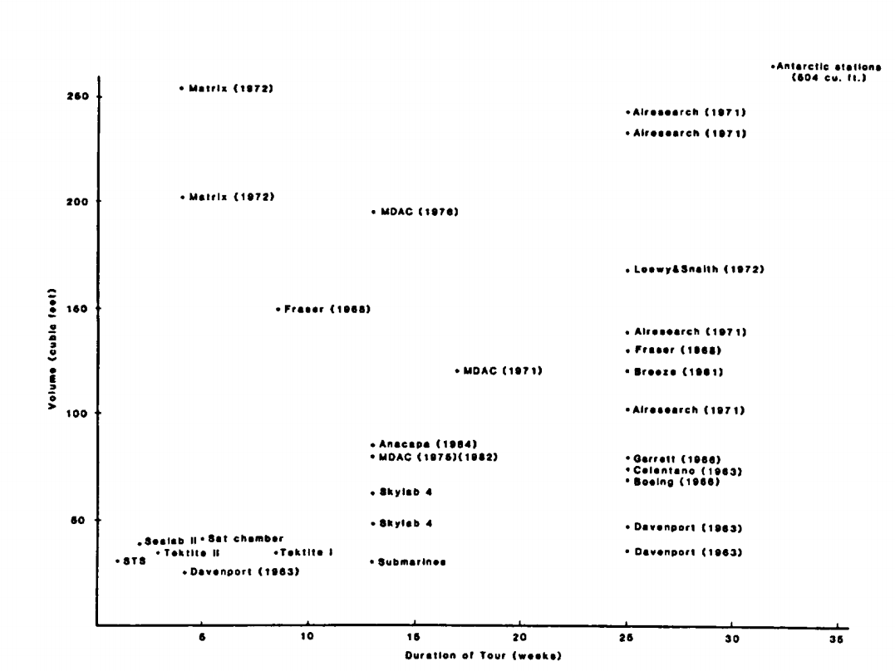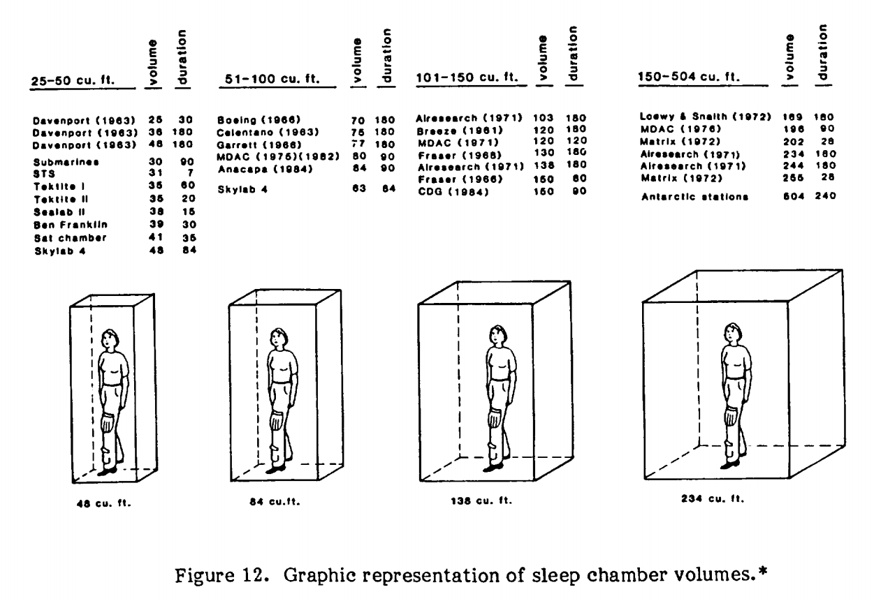

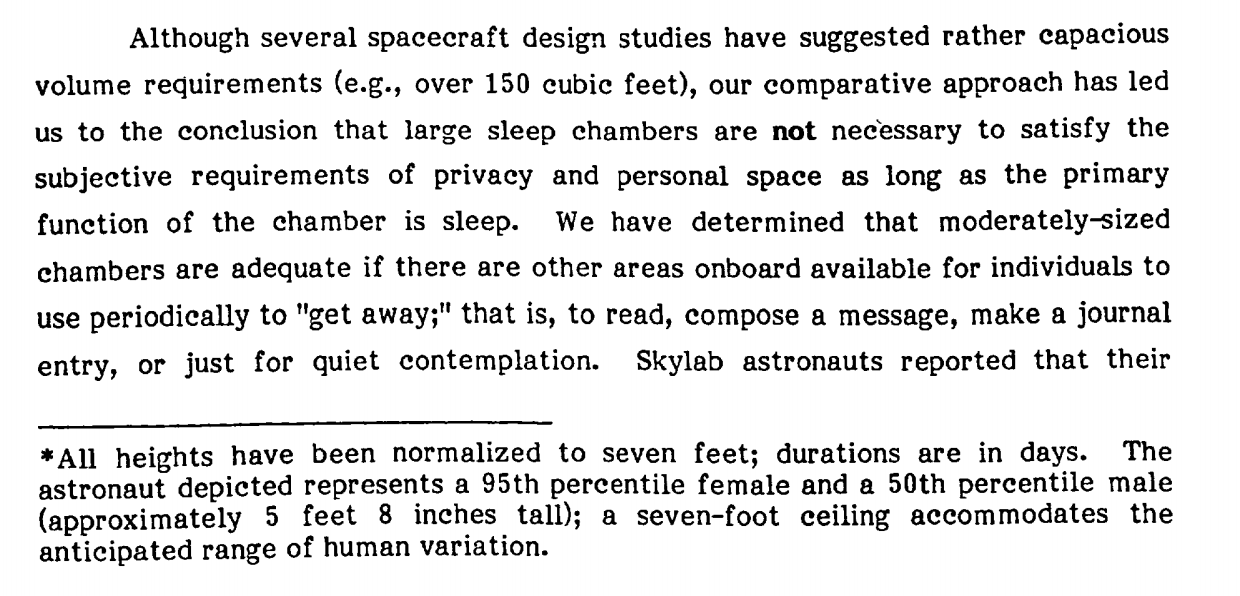

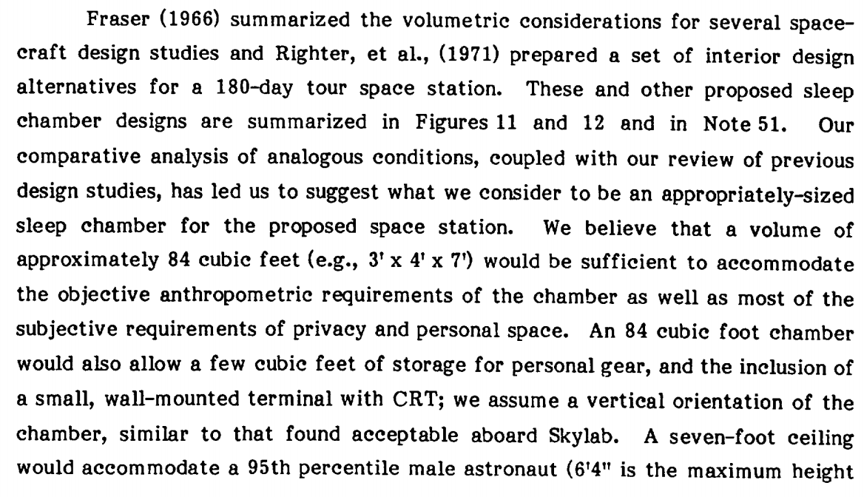

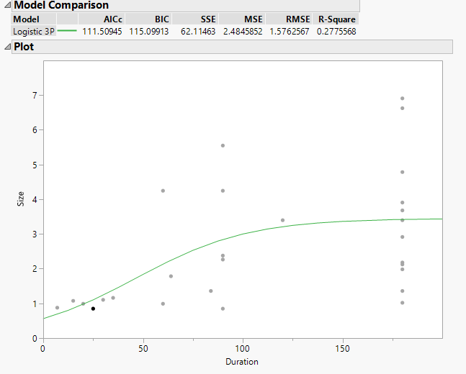

Plot made in JMP based on most of the points in the table with the duration and sizes of the habitats. Outliers were removed. Size is cubic meters. R value is .277, used logistic 3p

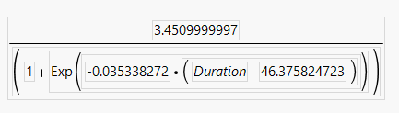

**JMP DOE – 10,000 runs**

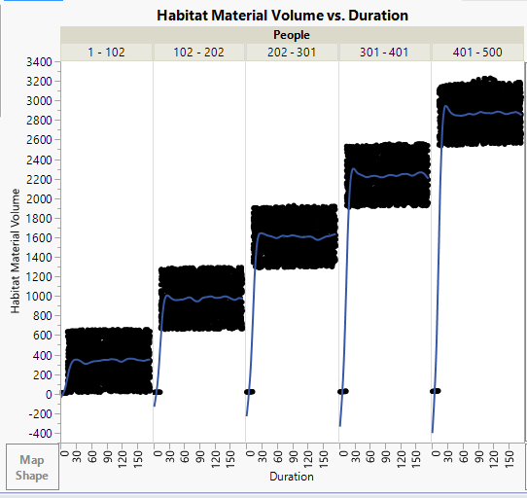

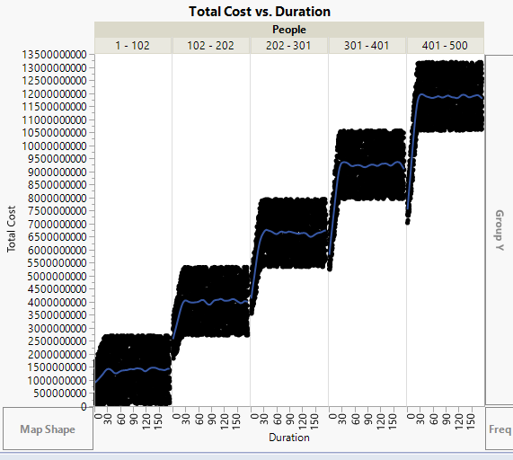

**Human Needs: Sustaining Life During Exploration – Nasa.gov**

When astronauts travel into space, NASA scientists determine how much food will be needed for each mission. For example, an astronaut on the ISS uses about 1.83 pounds (0.83 kilograms) of food per meal each day. About 0.27 pounds (0.12 kilograms) of this weight is packaging material. Longer-duration missions will require much more food.

A trip to Mars and back, for instance, may take more than three years and require the provision of thousands of kilograms of food. A crew of four on a three-year martian mission eating only three meals each day would need to carry more than 24,000 pounds (10,886 kilograms) of food.

**Food for Space Flight Space Food History – Nasa.gov**

The kinds of foods the Space Shuttle astronauts eat are not mysterious concoctions, but foods prepared here on Earth, many commercially available on grocery store shelves. Diets are designed to supply each Shuttle crew member with all the Recommended Dietary Allowances (RDA) of vitamins and minerals necessary to perform in the environment of space. Caloric requirements are determined by the National Research Council formula for basal energy expenditure (BEE). For women, BEE = 655 + (9.6 x W) + (1.7 x H) - (4.7 x A), and for men, BEE = 66 + (13.7 x W) + (5 x H) - (6.8 x A), where W = weight in kilograms, H = height in centimeters, and A = age in years.

**F.B. Salisbury, W.F. Campbell, J.G. Carman, G.E. Bingham “Plant growth during the greenhouse II experiment on the Mir orbital station,” Advances in Space Research, Volume 31, Issue 1, 2003,**

Super Dwarf wheat was harvested after 90 days.

**Closing the Loop: Recycling Water and Air in Space**

**https://www.nasa.gov/pdf/146558main_RecyclingEDA(final)%204_10_06.pdf**

The first Crew Exploration Vehicle (CEV) missions will be about 18 days long. For this short duration, regenerative systems are not cost effective. The CEV is considering using a device called a pressure swing bed, which would collect the CO2 and humidity condensate and dump it overboard. In a pressure swing bed, carbon dioxide and water are chemically absorbed onto a bed of beads that have an amine (an organic derivative of ammonia) chemical impregnated on them. Every 5–10 minutes the bed is exposed to the vacuum of space where the water and carbon dioxide are boiled off at the reduced pressure. Potable (drinkable) water will be stored in tanks and urine will be vented overboard. Regenerative systems will be cost effective for lunar outposts or Mars transit vehicles where missions may last 6 months to 3 years. (return)

The space shuttle, like the Apollo era capsules, uses canisters of lithium hydroxide (LiOH) instead of zeolite for s cost effective than zeolite systems so the ceflight. (return) CO2 scrubbing. After 20–30 days of use, the LiOH system becomes les current CDRA system used aboard the ISS will serve the needs of longer duration spaceflight

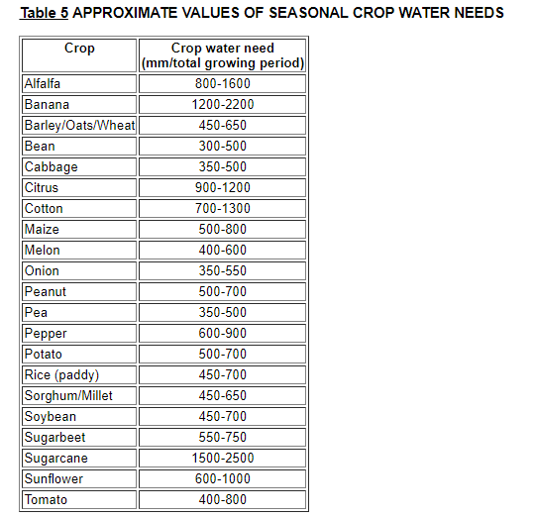http://www.fao.org/docrep/s2022e/s2022e02.htm

<https://www.arb.ca.gov/fuels/lcfs/workgroups/lcfssustain/hanson.pdf>

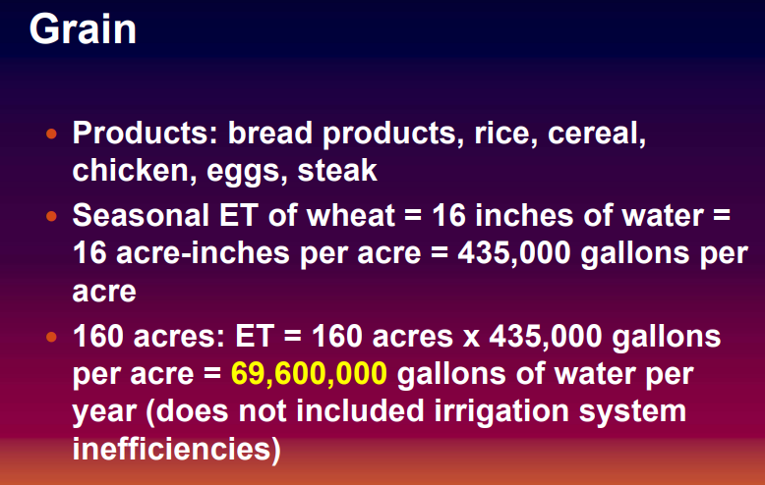

<http://www2.lbl.gov/Science-Articles/Archive/sb-EETD-Mars-wheat.html>

But is it sustainable month after month? Early calculations are optimistic. A six-person crew would eat 1.5 kilograms of wheat per day, a pace that could yield 203 kilograms of wheat-straw-derived activated carbon each year—enough to supply the crew's needs.

<https://www.nasa.gov/feature/nasa-plant-researchers-explore-question-of-deep-space-food-crops>

Talks about challenges with growing crops on mars, such as light, radiation, water, etc. Really could just be used as a citation source in paper

The South Pole Food Growth Chamber (SPFGC) is an automated hydroponic climate controlled chamber located inside the Amundsen-Scott South Pole station, which produces fresh vegetables and herbs, as well as a psychologically pleasurable environment for station personnel. The objective of this study was to document the SPFGC automated control practices, telepresence support, and resource utilization and crop production. Resource inputs included energy, water, plant nutrients, carbon dioxide, labor and the outputs included food, condensate water and oxygen. Data collected from January through October 2006 were used to evaluate the performance. Various plants (e.g. leafy greens, fruit crops, herbs and edible flowers) were grown within a hydroponic polyculture cropping system within the same controlled environment. Consumed resources included 1.1 kg d-1 of carbon dioxide, 0.21 kg d-1 of dry plant fertilizer salts, 1012 MJ d-1 (281 kWh d-1) of electrical energy, and production included 0.52 kg d-1 of oxygen and 2.8 kg d-1 of edible vegetables (fresh mass). The SPFGC system components and the control elements were described, and an energy balance analysis of the SPFGC was completed, and comparisons were made to various ALS food and oxygen production results.

Description, operation and production of the south pole food.... Available from: https://www.researchgate.net/publication/283250892_Description_operation_and_production_of_the_south_pole_food_growth_chamber [accessed Apr 10 2018].

https://ntrs.nasa.gov/archive/nasa/casi.ntrs.nasa.gov/20140005433.pdf

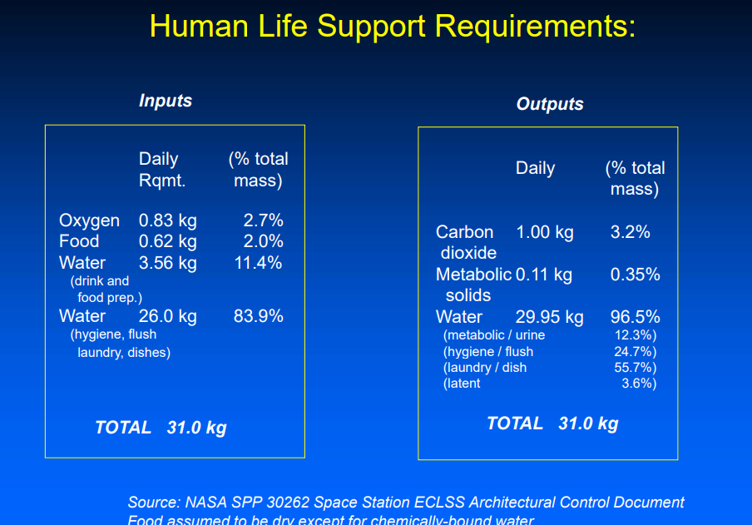

<https://spaceflightsystems.grc.nasa.gov/repository/NRA/tm206956v1%20living%20together%20%20in%20space.pdf>

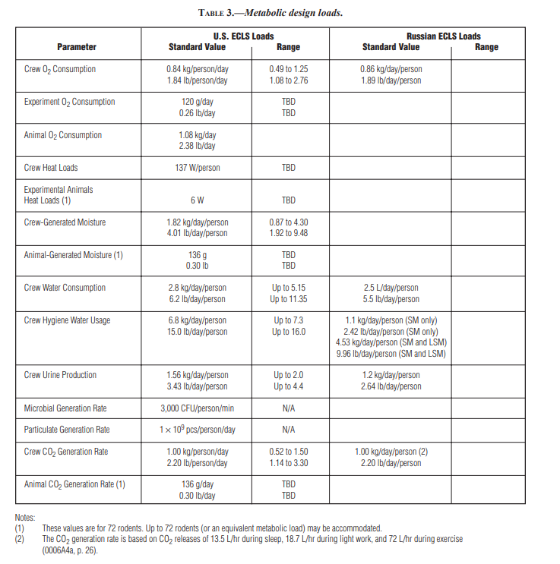

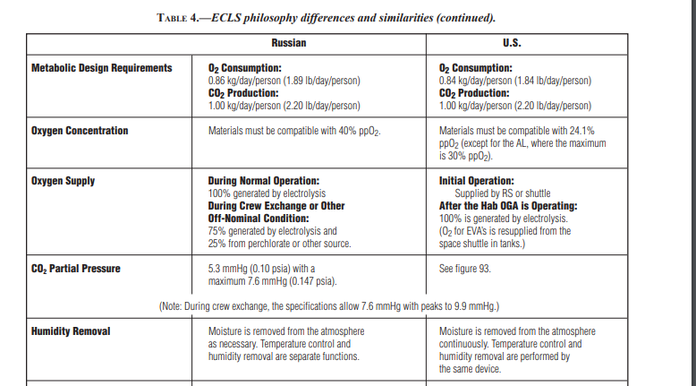

<https://www.nasa.gov/sites/default/files/atoms/files/ns_kilopower_fs_180111.pdf>

The Kilopower project was initiated because NASA mission planning includes exploration of places in the solar system—such as deep space beyond Jupiter’s orbit and the surfaces of Earth’s moon and Mars—where power generation from sunlight is difficult and power from radioisotope systems is limited by the fuel supply. For human exploration, multiple 10-kWe Kilopower systems could provide the 40 kWe initially estimated to be needed by NASA’s preliminary concepts for a human outpost, with the ability to add power as the outpost grows. For robotic exploration, 1-kWe Kilopower units enable abundant, reliable power for science and communications, and the potential to field deep space missions based on science return while conserving the limited supply of radioisotope fuel for its best opportunities. Characteristics of fission power that make it so beneficial for Mars outposts and

<https://mars.nasa.gov/files/mep/MMRTG_Jan2008.pdf>

The MMRTG generator is about 64cm in diameter by 66cm long and weighs about 45kg. It initially provides 2kW of thermal power and 120 watts of electrical power